REACT INTERVIEW QUESTIONS:
Reference: https://www.interviewbit.com/redux-interview-questions/
https://www.geeksforgeeks.org/reactjs/react-redux-interview-questions-and-answers/

Redux is one of the most popular state management libraries used today for building a complex application that requires global state management.
- Redux is a popular open-source state management library for JavaScript applications. It provides a way to centralize the state of an application in a single store, making it easier to debug, test, and reason about the state changes in the application.

- What are the advantages of Redux in React?
Centralized State Management: Redux stores state globally, accessible by all components.
Performance Optimizations: Prevents unnecessary re-renders by updating only changed data.
Pure Reducer Functions: State changes are handled by pure functions, returning a new object.
Storing Long-Term Data: Redux preserves data across page refreshes.
Supportive Community: A large community provides resources, best practices, and support.
3. What are pure functions in the context of Redux?
A pure function is defined as any function that doesn't alter input data, doesn't depend on the external state, and can consistently provide the same output for the same input. As opposed to React, Redux depends on such pure functions.

4. What are the key components of Redux architecture?
- Actions: Actions are a plain JavaScript object that contains information. Actions are the only source of information for the store. Actions have a type field that tells what kind of action to perform and all other fields contain information or data.
- Reducers: Reducers are the pure functions that take the current state and action and return the new state and tell the store how to do.
- Store: The store is the object which holds the state of the application
- Slice: initial values, reducer logic
- Dispatch: to move action to reducers
5. What’s the typical flow of data like in a React with Redux app ?
- User Interaction: Triggers an action in the component.
- Action Dispatch: The action is sent to the Redux store.
- Reducers Update State: The root reducer processes the action, updating the state by returning a new copy.
- Store Updates Components: The store notifies subscribed components, which then re-render with the new state.
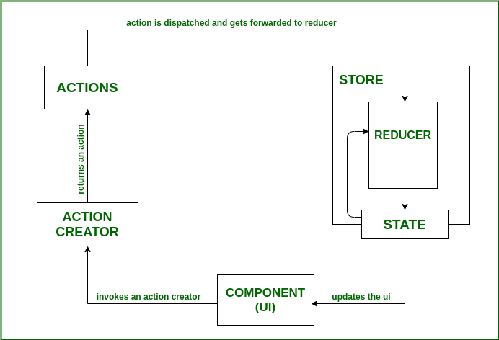
6. What is the purpose of the Provider component in React Redux?
- The Provider component makes the Redux store available to any nested components that need to access the Redux store.
- Since any React component in a React Redux app can be connected to the store, most applications will render a <Provider> at the top level, with the entire app's component tree inside of it.
7. What is middleware in Redux?
- Middleware is a function that sits between the action and the reducer, and can intercept and modify actions before they reach the reducer.
- It extends Redux with extra functionality.
8. What is a thunk in Redux?
- A thunk is a special function that is returned by another function, which can be used to delay the execution of an action, or to perform an asynchronous operation before dispatching the action.
- Thunks are a standard approach for writing async logic in Redux apps and commonly used for data fetching.
9. What is the difference between mapStateToProps() and mapDispatchToProps() in React-Redux?
mapStateToProps() is a function that maps the state from the Redux store to the props of a React component, while mapDispatchToProps() is a function that maps the action creators to the props of a React component.
10. What is the connect() function in React-Redux?
The connect() function is a higher-order function that connects a React component to the Redux store. It takes two arguments: mapStateToProps() and mapDispatchToProps().
11. State the core principles of Redux.
The core principles of Redux are as follows:
- Single source of truth: The global state of our application is always put away in an object tree inside one store.
- The state is read-only: The only way to change the state of our application is by emitting an action, an object explaining what has happened.
- Changes are made with pure functions: This principle means that in order to define how the state tree is being transformed by the actions, we have to write pure reducers

Steps to follow during redux in react:
- npm install @reduxjs/toolkit react-redux
- features/counter/counterSlice.js
import { createSlice } from "@reduxjs/toolkit";
const counterSlice = createSlice({
name: "counter", // slice name
initialState: {
value: 0,
},
reducers: {
increment: (state) => {
state.value += 1;
},
decrement: (state) => {
state.value -= 1;
},
incrementByAmount: (state, action) => {
state.value += action.payload;
},
},
});
export const { increment, decrement, incrementByAmount } = counterSlice.actions;
export default counterSlice.reducer;
- main.jsx or index.js
import React from "react";
import ReactDOM from "react-dom/client";
import { Provider } from "react-redux";
import { store } from "./app/store";
import App from "./App";
ReactDOM.createRoot(document.getElementById("root")).render(
<Provider store={store}>
<App />
</Provider>
);
- app/store.js
import { configureStore } from "@reduxjs/toolkit";
import counterReducer from "../features/counter/counterSlice";
export const store = configureStore({
reducer: {
counter: counterReducer,
},
});
- Counter.jsx

import React from "react";
import { useSelector, useDispatch } from "react-redux";
import { increment, decrement, incrementByAmount } from "./features/counter/counterSlice";
const Counter = () => {
const count = useSelector((state) => state.counter.value);
const dispatch = useDispatch();
return (
<div>
<h2>Count: {count}</h2>
<button onClick={() => dispatch(increment())}>+</button>
<button onClick={() => dispatch(decrement())}>-</button>
<button onClick={() => dispatch(incrementByAmount(5))}>
+5
</button>
</div>
);
};
export default Counter;

